IMPLEMENT BOOSTING TECHNIQUE (ADA BOOST) AND ANALYZE PERFORMANCE

AIM
To implement the AdaBoost (Adaptive Boosting) Classification Algorithm using Python to predict students' results based on hours studied, attendance, and assignments, and to evaluate the model using accuracy, confusion matrix, classification report, and feature importance visualization.

ALGORITHM
- Import the required Python libraries: Pandas, Scikit-learn, and Matplotlib.
- Load the dataset data.csv using Pandas.
- Select Hours_Studied, Attendance, and Assignments as input features.
- Select Result as the target variable.
- Split the dataset into training and testing sets using train_test_split(), with 80% for training and 20% for testing.
- Create an AdaBoost classifier with 50 estimators and a fixed random state of 42.
- Train the model using the training dataset with fit().
- Predict the results for the test dataset using predict().
- Evaluate the model using:
  - Accuracy score
  - Confusion matrix
  - Classification report (precision, recall, and F1-score)
- Extract the feature importance values from the trained model.
- Plot a bar chart to visualize the importance of each input feature.
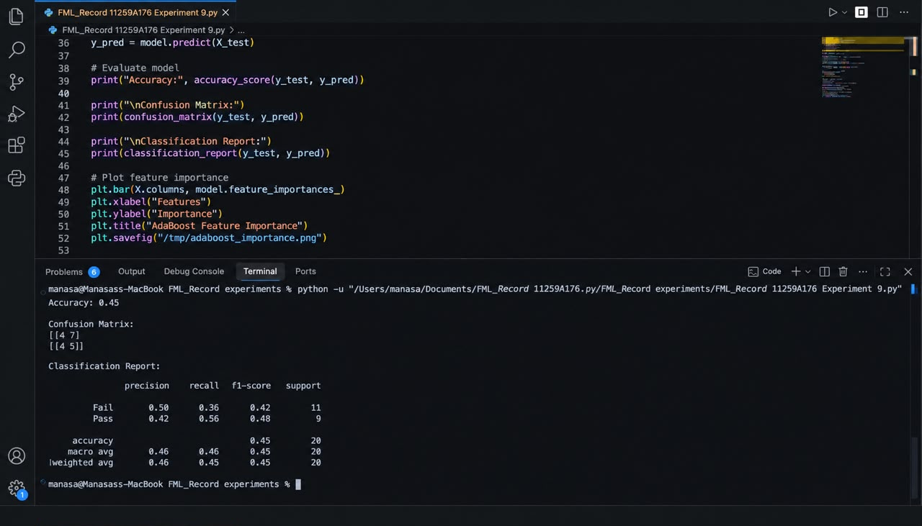

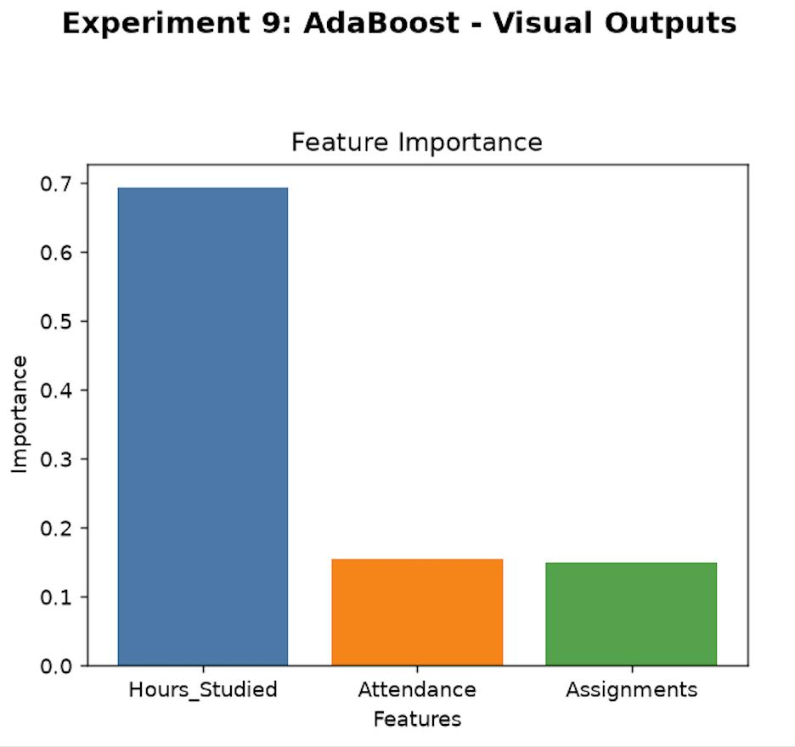RESULT
Thus, the AdaBoost Classification Algorithm was implemented successfully to predict student results using hours studied, attendance, and assignments.
The model's performance was evaluated using accuracy, a confusion matrix, and a classification report. A feature importance graph was also plotted to identify the relative contribution of each input feature to the prediction.

